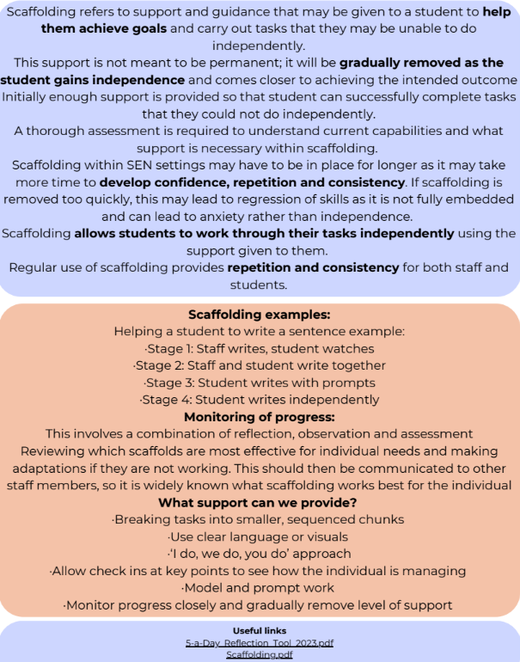
Topic of the month- Scaffolding
Scaffolding refers to support and guidance that may be given to a student to help them achieve goals and carry out tasks that they may be unable to do independently
This support is not meant to be permanent; it will be gradually removed as the student gains independence and comes closer to achieving the intended outcome
Initially enough support is provided so that student can successfully complete tasks that they could not do independently
A thorough assessment is required to understand current capabilities and what support is necessary within scaffolding
Scaffolding within SEN settings may have to be in place for longer as it may take more time to develop confidence, repetition and consistency. If scaffolding is removed too quickly, this may lead to regression of skills as it is not fully embedded and can lead to anxiety rather than independence.
Scaffolding allows students to work through their tasks independently using the support given to them.
Educating others involved in student care, such as teachers or TAs, allows them to also integrate this into practice. Regular use of scaffolding provides repetition and consistency for both staff and students
Scaffolding examples
Helping a student to write a sentence example:
- Stage 1: Adult writes, student watches
- Stage 2: Adult and student write together
- Stage 3: Student writes with prompts
- Stage 4: Student writes independently
Monitoring of progress
This involves a combination of reflection, observation and assessment
Reviewing which scaffolds are most effective for individual needs and making adaptations if they are not working. This should then be communicated to other staff members, so it is widely known what scaffolding works best for the individual
What support can we provide?
- Breaking tasks into smaller, sequenced chunks
- Use clear language or visuals
- ‘I do, we do, you do’ approach
- Allow check ins at key points to see how individual is managing
- Model and prompt work
- Monitor progress closely and gradually remove level of support
Useful links
5-a-Day_Reflection_Tool_2023.pdf
Scaffolding.pdf

