PEO model
What is the PEO model?
The Person, Environment, Occupation model is a widely used framework in occupational therapy that helps to understand how individuals engage in meaningful activities and different factors that contribute to this. It emphasises the relationship between these components and that they are all dependent and affected by each other. This relationship means that changes in one area can influence performance in others. The model is applicable across all ages and life circumstances meaning it offers a holistic lens to identify barriers and facilitators for both assessment and intervention. As a top-down model, PEO focuses on enabling engagement in occupations by considering the person as a whole, rather than just addressing isolated impairments (Bass et al., 2024; Christiansen et al., 2015; Wang et al., 2024).
In this work I will be focusing one specific SEN student I have worked with closely throughout my 8-week placement. To build a holistic understanding of this learner I have drawn on multiple sources of information, including their PBS plan, OT overview, SALT communication sheet and general observation of the individual and their engagement/behaviour around the college environment. Understanding this student through the PEO model can meaningfully inform future intervention by highlighting not only what the student struggles with but why those challenges might occur and where the most effective changes can be made. This approach can shape a more individualised, proactive and occupation centred approach to promote independence, engagement and wellbeing.
A PEO diagram and list of different aspects to consider is listed below:
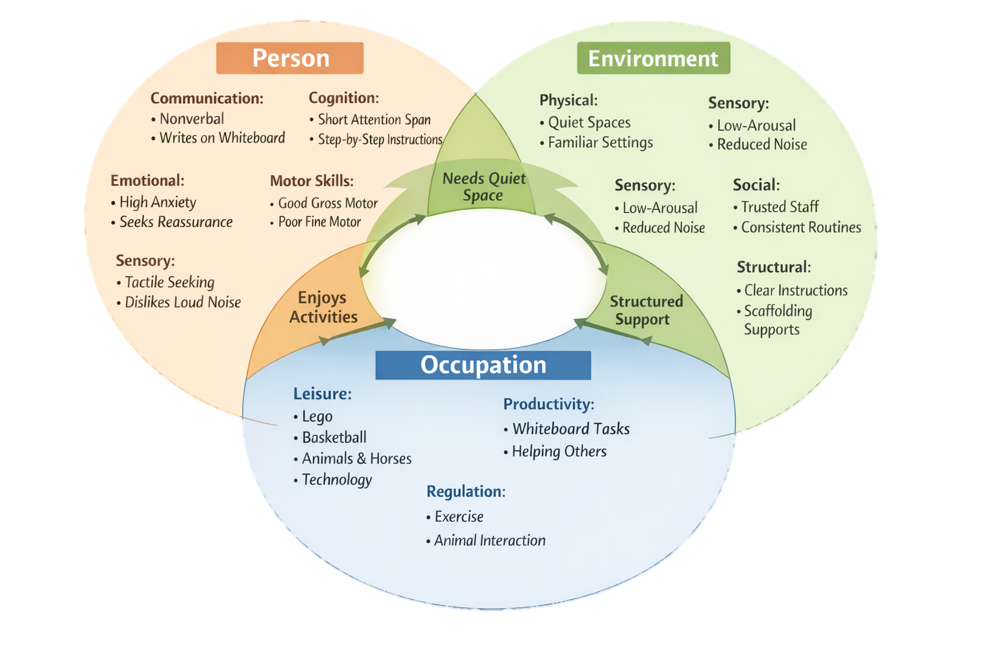
College student

Person
The person aspect of the PEO model captures the individual’s intrinsic characteristics. This includes strengths, abilities, preferences, cognitive skills, communication style and other personality traits. By capturing these intrinsic factors, it helps to enable professionals to understand how they engage, perform and participate in daily occupations. Personal factors influence not only what an individual is able to do but also how they experience tasks, how much support they need and what environments help or hinder them. When these individual and personal factors are understood and supported, participation becomes more successful, meaningful and empowering.
Sensory and communication
- Nonverbal in college – mainly communicates through writing or typing
- Speaks in a quiet tone at home but is verbal
- Enjoys tactile input
- Prefers quieter spaces with reduced sensory input
- Does not like loud noise or busy environments
- Struggles with unfamiliar people
- Does not like unfamiliar environments
- Uses a whiteboard to produce written work
- Requires clear, concise, simple instructions
- Requires additional processing and response time
Cognitive and emotional
- Short attention span; easily distracted
- Needs support to initiate and complete tasks
- Requires step by step instructions
- High anxiety, low confidence
- Attachment difficulties
- Significant difficulties identifying, regulating and expressing emotions
- Seeks reassurance and validation from trusted staff
- Fire related anxieties
- Lacks awareness of danger- strangers and roads etc
Motor and functional skills
- Independent in walking, sitting and transferring
- Independent in dressing, washing and hygiene
- Good gross motor skills
- Reduced fine motor skills due to finger dexterity difficulties
Personality and strengths
- Hardworking, friendly, introverted, creative
- Enjoys showing his work and receiving praise/validation
- Responds well to reassurance and praise
- Calms through physical activity e.g. basketball
- Enjoys small animals and horses

Environment
The environment section of the PEO model focuses on all external factors that shape how a person engages and is essential to consider as this can support or hinder participation. Understanding environmental influences is crucial because modifying the environment is one of the most effective and least intrusive ways to improve occupational performance. It allows professionals to increase comfort and create conditions where the individual can use their strengths and engage more confidently and independently. This aligns with core OT principles of person-centred practice and occupational justice, ensuring the individual is not expected to change but is supported through environments that fit needs and promote meaningful engagement.
Physical environment
- Benefits from quiet, low arousal spaces
- Needs minimised distractions and reduced noise
- Requires predictable, structured environments
- Unfamiliar environments increase anxiety
- Needs proactive sensory regulation (not too loud, not under stimulating)
Social environment
- Needs trusted staff for reassurance
- Struggles with unfamiliar people
- Requires consistent routines, expectations and boundaries
- Needs high levels of scaffolding and visual support
- Needs adults who understand his communication style and anxiety profile
Environmental support
- Chunked learning
- Visual supports
- Step by step guidance
- Additional processing time
- Clear routines and predictable transitions

Occupation
Occupation section of the PEO model focuses on meaningful activities, roles and tasks that make up an individual’s life. Occupations are central for providing purpose, identity and motivation. By examining the occupation itself and its steps, complexities and meaning it holds to the individual, Ots can identify ways to increase engagement. Understanding this component is essential for ensuring intervention remains occupation centred, meaningful and aligned with what matters most to the individual.
Preferred and motivating occupations
- Lego, technology, helping others, basketball, spending time with small animals and horses
- Engages in hands on practical tasks
Occupational challenges
- Difficulty sustaining attention
- Needs support to initiate and complete tasks
- Anxiety impacting engagement
- Sensory sensitivities affecting participation
- Emotional regulation difficulties impacting social and learning occupations
How can this inform future learning/intervention?
Personal factors such as anxiety, emotional regulation difficulties, short attention span and fine motor challenges show that future interventions should prioritise emotional regulation, sensory regulation, confidence building and possibly alternative methods of recording work/ communication e.g. continued use of whiteboards, assistive technology
Environmental insights highlight the importance of quiet, predictable, low arousal spaces, trusted staff and consistent routines. This means future planning should consist of focusing on maintaining stable environments, reducing sensory load and ensuring transitions are well supported and prepared. Understanding individual triggers can allow staff to plan, reducing stress and increasing participation.
Occupational demands reveal which tasks are meaningful and motivating (e.g. Lego, basketball, animals) and which require adaptation. This can guide the use of motivating occupations as regulation tools and inform how academic tasks can be scaffolded.
Important adaptations
- Consistent, predictable routines
- Clear visual structure - visual schedules, step by step task breakdowns and reassurance reduces cognitive load
- Preparing learner ahead of time - using visuals, timers, written prompts reduce behavioural distress linked to unfamiliarity
- Scaffolding
- Use of motivating activities
- Support communication through preferred methods or introduce new methods (e.g. typing into iPad and using audio read aloud features to support communication and access to learning)

REFERENCE
Bass, J. D., Marchant, J. K., de Sam Lazaro, S. L., & Baum, C. M. (2024). Application of the person–environment–occupation–performance model: A scoping review. OTJR: Occupational Therapy Journal of Research, 44(3), 521–540. https://doi.org/10.1177/15394492241238951
Christiansen, C. H., Bass, J., & Baum, C. M. (2015). Occupational Therapy: Performance, Participation, and Well-Being (J. D. Bass, C. M. Baum, & C. H. Christiansen, Eds.; Fourth edition). CRC Press. https://doi.org/10.4324/9781003522997
Wang, Z., Wu, P., Li, M., Chen, X., & Lin, C. (2024). Perceived effectiveness of the person–environment–occupation innovative teaching model in rehabilitation therapy students. BMC Medical Education, 24(1), Article 1180. https://doi.org/10.1186/s12909-024-06196-2

